Earl J. Koobs Nature Area
You are Invited To Visit
Veterans Day November 11th and Memorial Day Each Year
10 A.M. to 2 P.M.
Colors presented at 11A.M.
Gates open from Garfield Elementary School’s playground
and the east parking lot of La Sierra Community Center
Please join us on these special days to honor
and remember those who served our country
If any questions, call Linda & Keith Jones at 944-2393
or the Garfield Elementary School Office at 575-2349
www.calcadetcorps.org
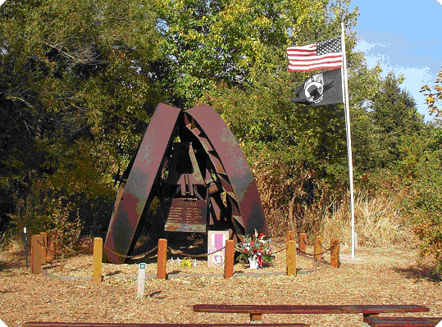
La Sierra High School
Vietnam Veterans Memorial

